TASK 1

5.1 Example After Changing Values

***Before Sorting***

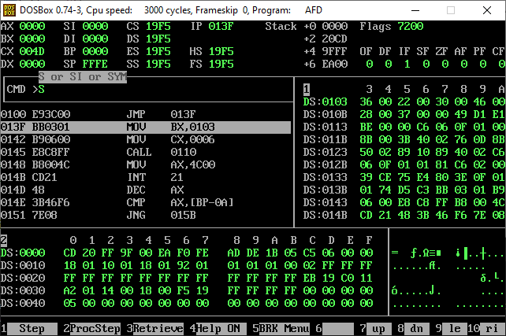

***When Subroutine Is Called***

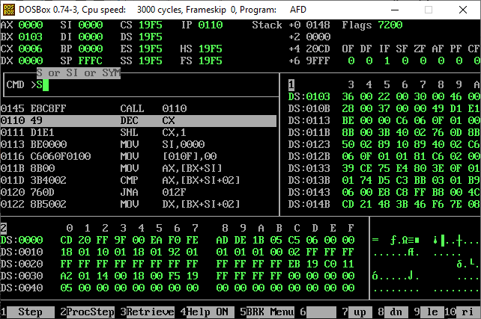

***Sorted***  
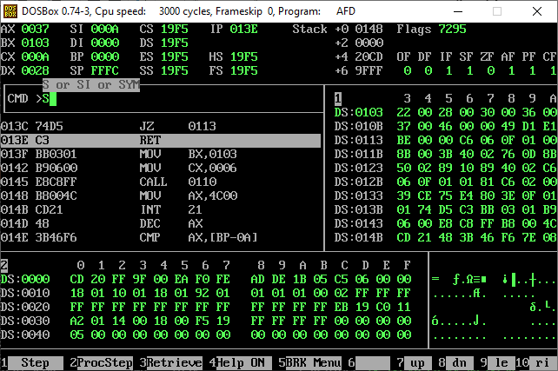

***After Subroutine Returns***

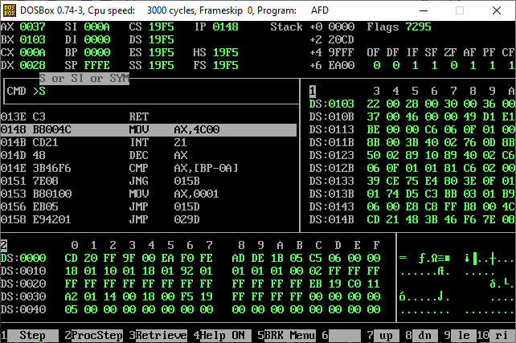

TASK 2

5.2 Example Running As It Is

***Before Sorting***

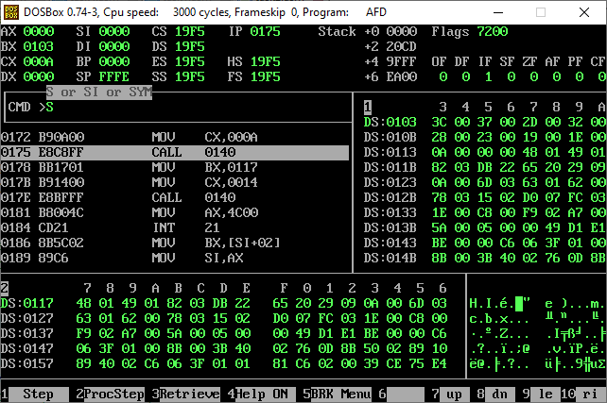

***After Sorting***

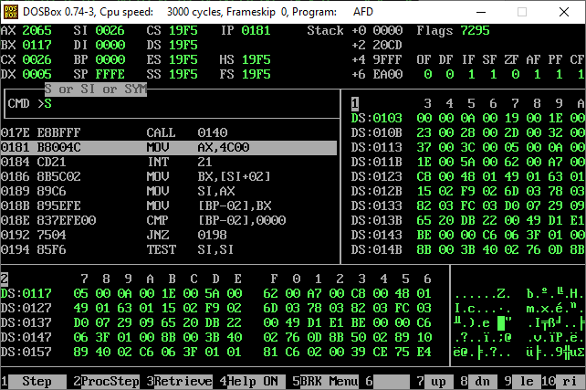

Task 2

Example 5.2 After Changing Values

***Before Sorting And Calling Subroutine***

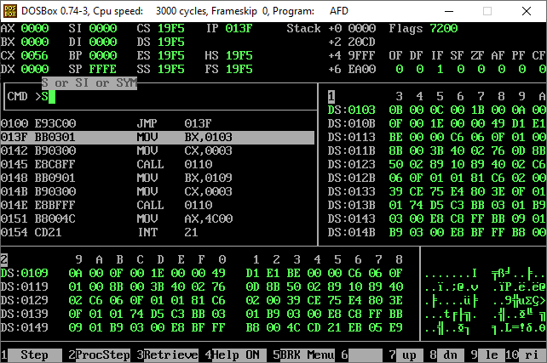

***After Sorting First Data Set And Before Returning From The Subroutine For The First Time***

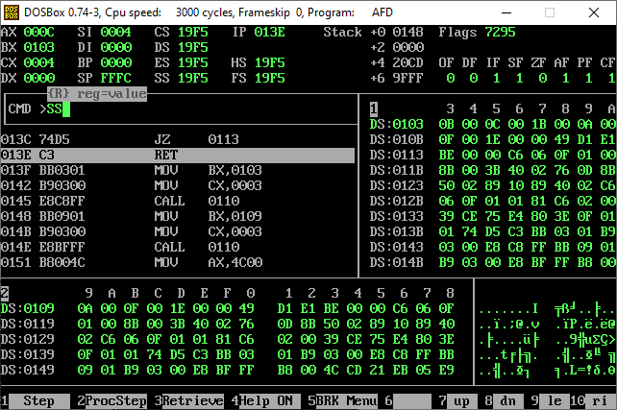

***After Sorting First Data Set And Returning After The First Subroutine Call And Second Data Set Is Still Not Sorted***

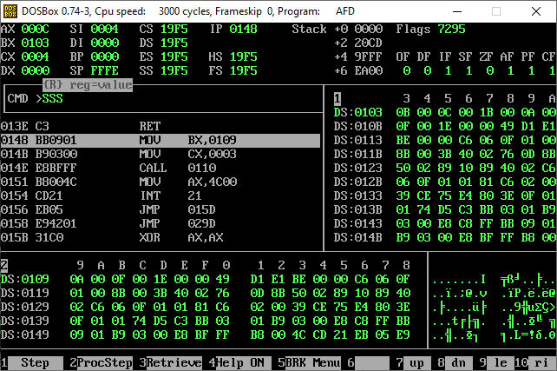

***After Calling The Subroutine For The Second Data Set Which Is Not Sorted Till Now As Can Be Seen The Stack Has Pushed The Address Where It Will Return After Sorting Out The Data***

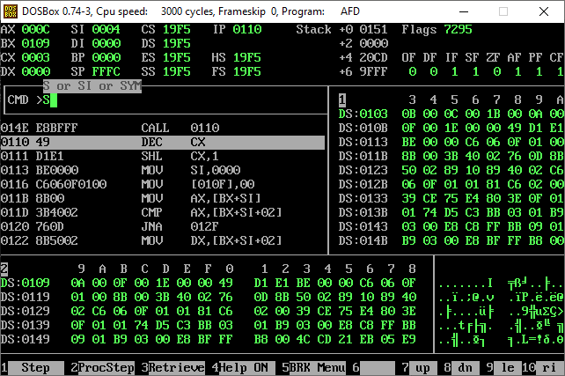

***Second Data Set Is Also Sorted And The Subroutine Has Returned***

***So Both The Data Sets Are Now Sorted***

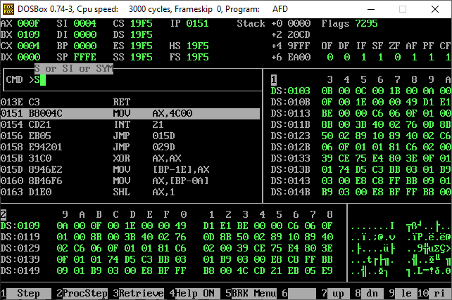

HENCE THE MAIN DIFFERENCE IN BOTH THE EXAMPLES IS THAT , THAT IN THE 5.1 EXAMPLE THERE IS ONLY ONE DATA SET AND THE SUBROUTINE IS CALLED ONLY ONCE FOR THAT DATA SET ONLY HOWEVER IN 5.2 THERE ARE 2 DATA SETS AND THE SUBROUTINE IS CALLED TWICE FOR BOTH THE DATA SETS WHICH SORTS OUT BOTH THE DATA SETS.